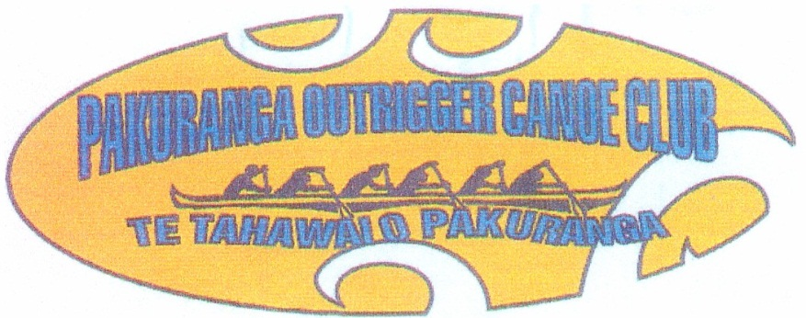

POCC are running a series of regattas with two races on each day. Being on the Estuary the conditions will be near on perfect, so the racing will be “Hard N Fast”. This is a great new way to get through the winter months and should prove both exciting and challenging
With reference to the “Covid19 Virus”
Please refrain from all un-necessary physical contact and please respect others personal space.

Programme
Saturday 26th June 2021
High Tide: 08.14am
- 07.00am Race 1 Registration open
- 08.00 am Karakia
- 08.00 am Race 1 Briefing (5km) All W6 Divisions (including novice)
- 08.30am Race 1 start
- Hot Soup on return

- 07.00am Race 2 Registration open
- 09.30am Race 2 Briefing (10km) All W6 Divisions
- 10.00am Race 2 start
- Hot Soup on return
All registrations must be on-line at the NKOA (Waka Ama NZ) website.
All race fees must be paid on-line by participating Clubs: Acc 38-9018-0482221-02
REGISTRATIONS CLOSE Wednesday 23th June, 2021 6.00pm
There will be no registration on the day
Entry Fees: Race 1 Competitors $10.00, Race 2 Competitors $20.00

